125 Canterbury Road, Westgate-On-Sea, Kent, CT8 8NL
Tel: 01843 830150 Email: info@staugustines.uk.com

The perfect venue
for any celebration
- A choice of impressive function rooms from 20-250
- Rooms located on the ground floor
- Ideal photo opportunities whatever the season
- Outdoor area for summer functions
- Licensed till 12pm
- Free Car parking

2023
From birthday parties and anniversaries,
to lunches, family gatherings and office parties,
St Augustine’s is the perfect venue for any occasion

Our team of experienced professionals at St Augustine’s prides itself on quality of service and attention to detail. Whatever your requirements, we will always go the extra mile to ensure your event is exactly as you wish. St Augustine’s provides a whole host of options to make planning your party as easy as possible with a variety of function rooms to suit your needs from 20 to 250 guests, and tempting buffets to formal dining, we offer an array of mouth-watering dishes to suit any palate.

PARTIES

Whether you are young or old, looking for a wild party night or a more formal occasion, St Augustine’s can offer something for everyone and have function rooms accommodating up to 250 guests. However, we don’t just cater for larger parties. If you are looking for a more intimate affair, to celebrate a birthday or an anniversary, St Augustine’s can help arrange the ideal surroundings and a menu to suit your needs.

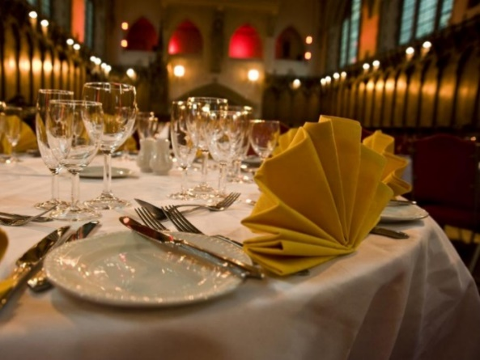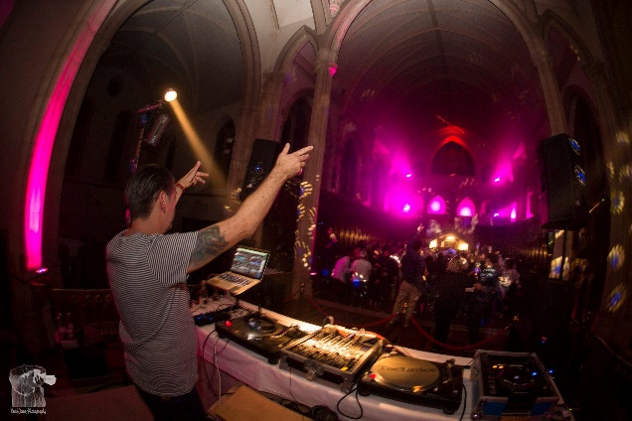

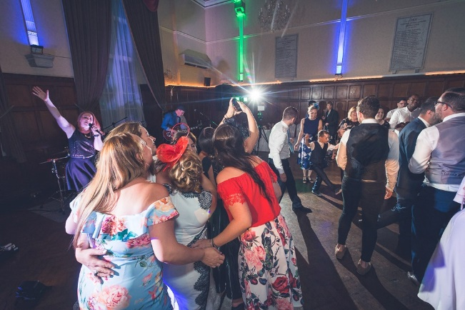

PROMS
Catering for both Year 11 and 6th form proms with a choice of impressive function halls to suit guest numbers and preferred leavers night themes.
A range of buffet menus from £12.50pp - £16.50pp and a modern young menu for a 3-course meal at just £22.95pp
All prom quotes include.
- Room Hire
- Buffet or sit-down meal.
- Welcome Drink
- Security
- DJ
Contact us now to secure your date and get a personalised quote for your event.

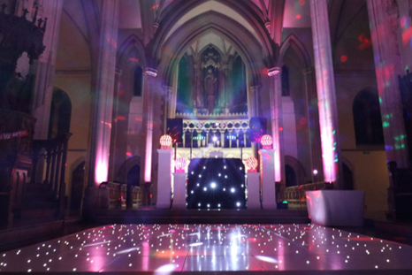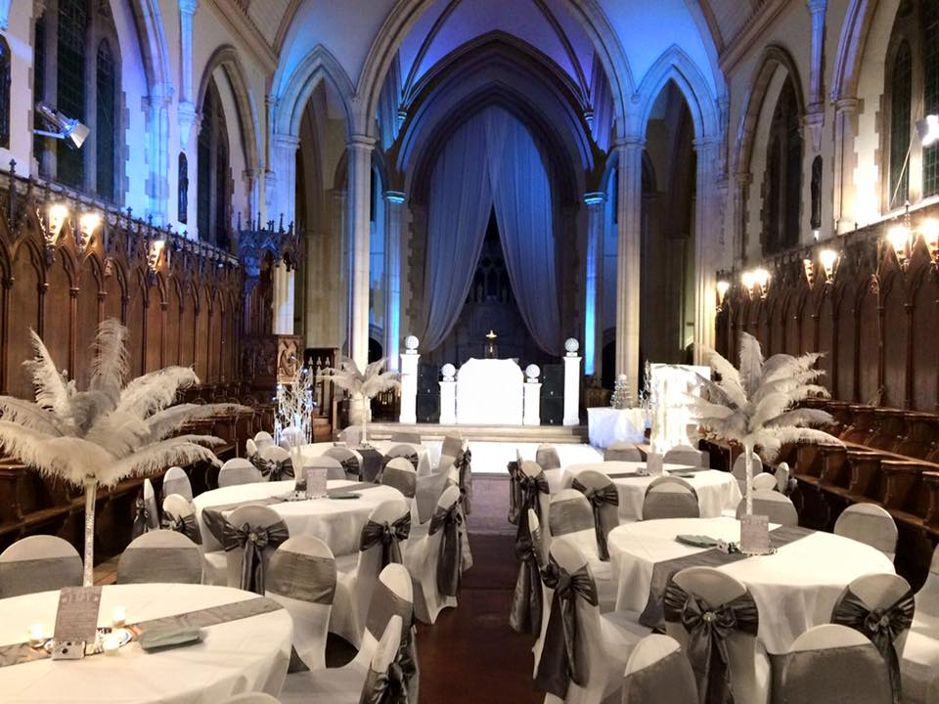

WAKES
Losing someone can be difficult, without the added pressure of organising a memorial service or wake. At St Augustine’s we can help eliminate any stress by helping you plan a seamless day in keeping with your needs and providing a fitting tribute to your loved one. Whether you require a service of remembrance held in our onsite chapel followed by a buffet lunch or simply a private room in which to hold a wake, we can help you decide the best options for you, your family and guests.

CHRISTMAS PARTIES

Whether you’re looking for somewhere to host your works Christmas party or simply for somewhere to take your loved ones for a festive treat, St Augustine’s can relieve the pressure by organizing something truly fabulous. At our Christmas party nights, we offer a mouth-watering 3-course sit down dinner, decorations, and DJ to celebrate the festive season in festive style. Or, if you'd prefer a daytime bash instead, we can also hold Christmas lunch parties for you and your work colleagues from 12.30pm. Alternatively, let us take the strain of preparing your Christmas Day or New Year’s Eve dinner, as we can host the meal allowing you to simply sit back, relax and enjoy the festivities.

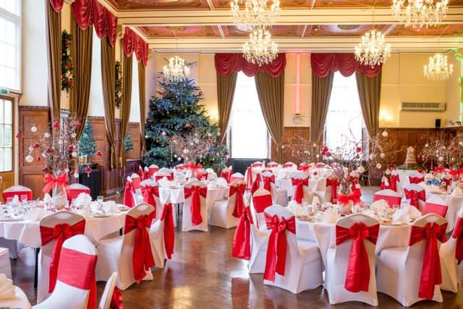

CHOOSE THE RIGHT ROOM FOR
YOUR OCCASION

We offer a wide range of room choices to suit any party.

Chapel

This French style chapel, built in the 1900’s contains 350-year-old carvings from Paris and can be converted into your essential party domain, with the ability to cater for up to 100 for a formal dinner or up to 250 for an informal buffet and dance. Complete with LED lighting to match your party colours, it is the ideal setting to astound you.

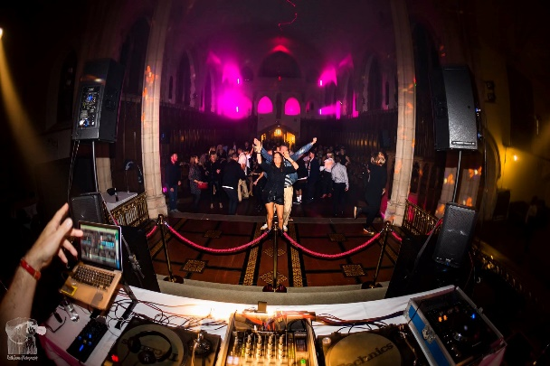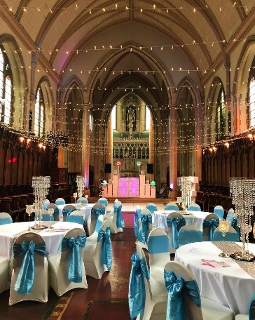

Ruby Room
This is the ideal place to celebrate your Christmas parties or larger functions. Ladies Nights, Dinner & dance and much more. With capacity of up to 220 guests for formal dining, air conditioning and a licensed bar, the Ruby room is the perfect place to dance the night away in style.

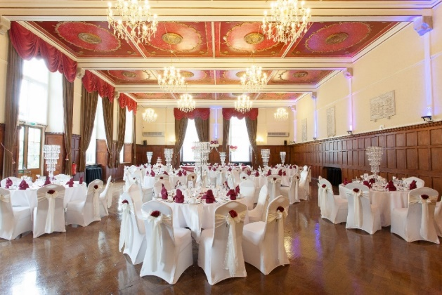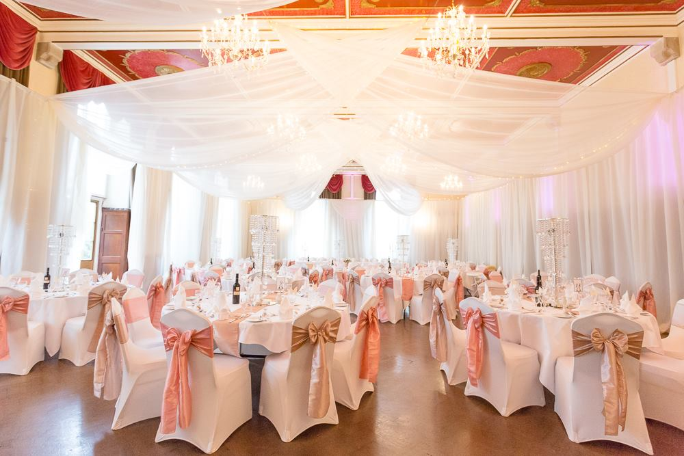

Oak Room
Complete with a gothic arched ceiling and stunning chandeliers, the Oak room is perfect for the more intimate occasions such as an anniversary or family lunch with capacity between 20 - 70 people for formal dining.

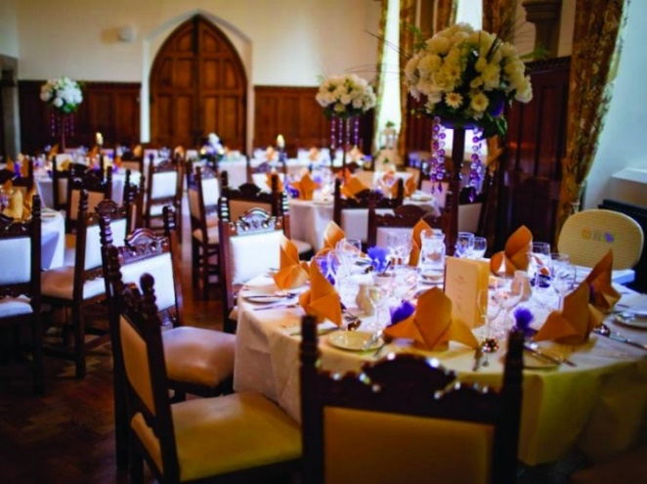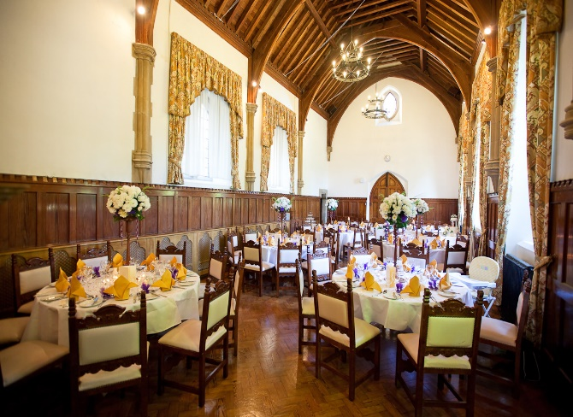

The Drawing Room
With oak panelled walls and art deco chandeliers, this room offers a spacious and relaxed environment, suitable for formal dinners of up to 80 guests or lunches for 20 guests upwards. Our team of experienced professionals at St Augustine's prides itself on quality of service and attention to detail. We will always go the extra mile to ensure your event is exactly as you wish.

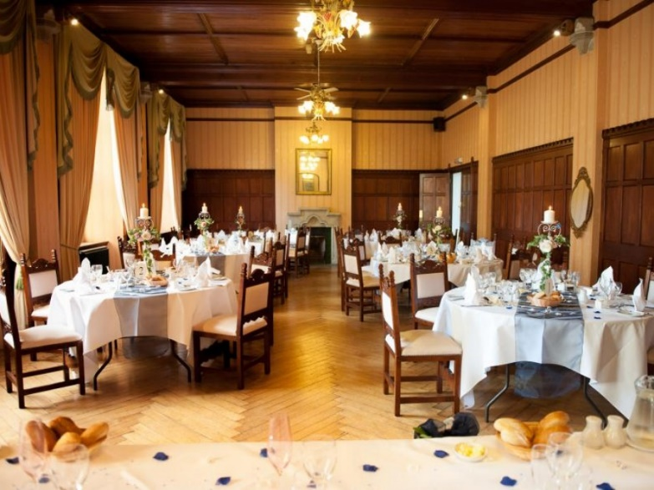

Afternoon Tea
Our delicious home-made afternoon tea is available most days of the week. Ideal for baby showers, birthdays or just a get together; simply call the venue to confirm availability and reserve your table.

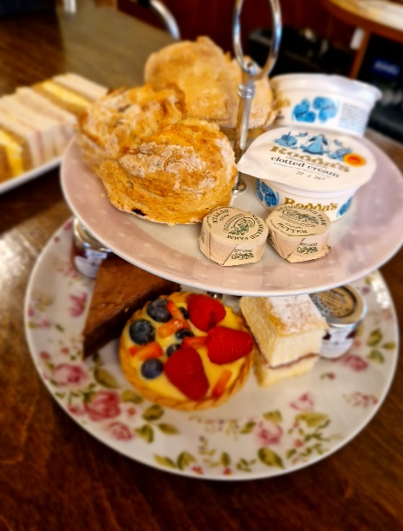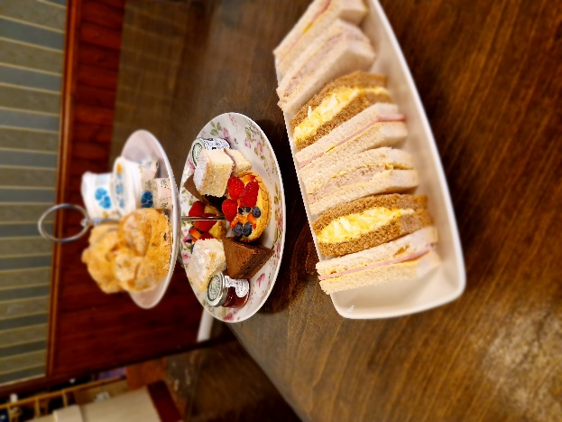
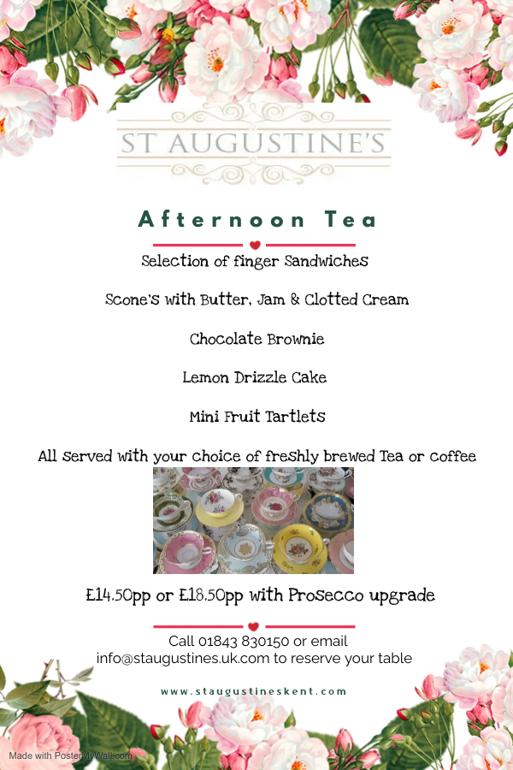

Party Buffet - £15.95pp
Dishes are homemade therefore most dishes can be adapted for special dietary requirements (Gluten Free, Vegan, Dairy Free, etc.)
Choice of 8 items
Hot & Cold
Chipolata’s with Honey & Mustard
Fresh Homemade Sausage Roll
Southern fried breaded Chicken strips
Lamb Koftas in Pitta with mint dip
Mini Tomato Arancini
Vegetable Spring Rolls
Vegetable Quiches
Homemade Artisan Pizza
Selection of freshly cut Sandwiches
Spiced Potato Wedges
Crudites & Dips

Assorted Salad Bowls - £10 per bowl

Dessert Buffet Options
Chocolate Brownie
Flapjack
Assorted Mini Muffins

Additional Extra’s
Cheese Platter
Cheddar, Stilton, Brie, served with apple and homemade chutney, dates, and artisan crackers
Small Platter – serves approx. 40 £100
Large Platter – serves approx. 80 £200

Three Course Lunch menu
£23.95

Artisan breads & Butter (£0.50 + supplement)

STARTERS

Tomato & Basil Soup

Ham Hock served with Sourdough, Rocket & Piccalilli

Salmon Fishcake served with a Pepper Coulis

MAIN COURSE

Baked Cod Loin with a Herb Crust on a bed of braised leeks and samphire served
with new Potatoes and a White Wine sauce

Gnocchi in Confit Tomato Sauce served with seasonal roasted vegetables

Chicken Supreme served on a Bacon Savoy Cabbage with Shallot Purée & wild Mushroom Sauce

DESSERTS
Chocolate Mousse served on Chocolate Soil with Chocolate Chards & sharp Raspberries

Banoffee Pie with Salted Caramel sauce

Sticky Toffee Pudding with Toffee Sauce & Vanilla Ice Cream

Dishes are homemade by our Executive Head Chef and therefore, most dishes can be adapted for your dietary requirements (gluten free, vegan, etc.)

Three Course Set Dinner
£29.95

Artisan breads & Butter (£0.50 + supplement)

STARTERS
Smoked Salmon served on toasted Sourdough with a Celeriac Remoulade, Lemon & Cucumber
Butternut Squash & Thyme Soup (V, Ve, GF, DF)
Pork & Chorizo Terrine (GF)
Mushroom Camembert Al Forno with toasted Ciabatta croutes with
Tarragon infused oil (V, Ve)

MAIN COURSE
Crusted baked Cod Loin served on new potatoes, tender stem Broccoli & White Wine sauce
Gnocchi in Confit Tomato sauce, Seasonal vegetables with Thyme & dressing (GF)(Vegan)
Braised Beef on Mustard Pomme Puree Onion Jus & crispy Leeks
Chicken Supreme on Bacon Savoy Cabbage with Shallot Puree & wild Mushroom sauce (GF)

DESSERTS
Chocolate Mousse on Chocolate soil, Chocolate shards & sharp Raspberries (GF)
Banoffee Pie with Salted Caramel
Sticky Toffee Pudding with Toffee Sauce & Ice Cream
Cheese selection with homemade Chutney, Dates & Artisan Crackers

Dishes are homemade by our Executive Head Chef and therefore, most dishes can be adapted for your dietary requirements (gluten free, vegan, etc.)
Terms of Business for Functions, And related Events

To avoid any misunderstandings in respect of this booking, the following are the Terms of business which apply to all bookings relating to Weddings, Functions and related Events.
In these terms of business, the expression 'Venue' means the St Augustine’s operated by St Augustine’s, Client' means the person, firm or company booking or staying at the Venue and 'Event' means the wedding or function and activities and events relating to that wedding or function.
1. Booking confirmation
1.1 Any booking is provisional until the Venue receives a signed copy of these terms from the Client or written confirmation of booking from the Client. The venue must also receive a deposit to confirm the booking fully. receipt of which will be deemed to be the Client's acceptance of these Terms.
2. Prices
2.1 All rates exclude VAT at the current rate.
2.2 Prices quoted are subject to variation up to 12 weeks prior to arrival, after which, except for variations due to Client requirements, they may only vary due to changes in VAT or other reasons outside the Venue's control, in which case they will immediately be notified to the Client. In the latter case, the Client will have the right to cancel the Booking without cost.
2.3 All prices are as quoted and no other discount, promotion or reward scheme may be applied in respect of this booking.
3. Availability
3.1 All rooms, facilities and rates offered by the Venue are subject to availability, the time of booking and the discretion of the Venue manager.
4. Numbers
4.1 Provisional minimum numbers will be required from the Client at the time of booking and the Venue's minimum charge for the facilities booked will be based on those numbers.
4.2 At least 28 days prior to arrival, the Client will provide the Venue with up-to-date guest numbers.
4.3 At least 14 days prior to arrival, the Client will provide the Venue with final guest numbers. The final charge to the Client will be calculated using this number or the actual number attending, whichever is the greater, provided that the minimum charge is exceeded.
4.4 If any reduction is made by the Client to the final numbers less than 14 days prior to arrival, the Venue may charge the Client 50% of the per head charge for each guest not attending. If less than seven days' notice is given, each non-attending guest will be charged to the Client at the full price per head.
4.5 In the event of a reduction in the numbers booked, the Venue reserves the right at any time up to 14 days prior to arrival to reallocate the booking to suitable alternative facilities or accommodation within the venue
5. Deposits & Payments
5.1 Deposits are payable as follows:
On booking A non-refundable deposit of £500, OR as determined by the venue, of not less than 10%, based on provisional numbers as defined in clause 4.1
9 months before the Event, a further non-refundable deposit of £1500 and 28 days before the Event the balance outstanding must be paid in full.

5.2 Failure to pay a deposit within seven days of being requested to do so entitles the Venue to treat the booking as cancelled.
5.3 If the Client cancels, any deposit will be set against cancellation charges.
6. Cancellation and postponement
6.1 Cancellations or postponements by the Client must be in writing and will result in the charges below becoming due. In each case, the percentage change is based on the advance notice of cancellation given and applies to the estimated total cost of the booking.
- More than 36 weeks prior to the event, the non-refundable deposits are retained by the venue 100%
- Between 12 weeks and 36 weeks an additional 25% of the estimated cost of the booking
- Within 12 weeks of the event an additional 50% of the estimated cost of the booking
- Less than 7 days 100% of the estimated cost of the booking
6.2 The Venue will try to re-let the allocated rooms and a reduction of the cancellation charge may be made if the Venue is successful.
6.3 The Client also agrees to reimburse the Venue for any costs incurred by it arising from the consequential cancellation of the Venue's arrangements with third parties.
6.4 Should the client book an outdoors wedding and pay an additional supplement cost. This cost will not be reimbursed to the client if weather conditions cause this to be cancelled. A suitable alternative room will always be offered in exchange, or the monetary value of this supplement may go towards a bar tab but will not be refundable in cash, only in venue credit

